
National College of Information Technology (NACIT)
(Blantyre Campus)
Advanced Diploma in Computing (Level5DC)
Computing Project Design Document

Title: Sales and Inventory Management System for Entyre Limited Company

Name: FARAI MZUMARA
Student ID Number: P00205641
Email Address: mzkfaraimzk@gmail.com
Phone Number: 0981474654
Project Coordinator: Ms. Mwausegha
Project Supervisor: Mr. Banda

Abstract
Entyre Limited firm, a tire distribution and automotive services firm founded in 1994, plans to update and optimize its business processes with the help of the Sales and Inventory Management System. The technology solves significant operational issues that the current manual procedures create and impede the expansion and efficiency of businesses.

Key functionalities include Effective user registration and authentication, together with role-based access control that guarantees safe system access, are important features. Employees can keep comprehensive client records for both individual and business clients thanks to customer management features. With automatic inventory movement calculations, product inventory management offers real-time tracking of tire specs, pricing, supplier details, and stock levels.
Strong sales transaction processing with thorough audit trails, automatic invoice production with business branding and several format options, and integrated payment processing that supports both conventional payment methods and mobile platforms like Mpamba and Airtel Money are all components of the system. While thorough financial reporting produces daily sales summaries, monthly income statements, and inventory valuation reports, stock level monitoring automatically sends out alerts when inventory drops below preset minimums.

Additional features include adaptable site design for multi-device usability and quotation management for customer service requests. Eliminating manual record-keeping errors, increasing operational efficiency through automation, improving customer happiness through quicker service delivery, and facilitating better business decision-making through accurate real-time reporting are some of the high-level outcomes. Through the integration of these features, the system seeks to improve Entyre Limited's operations, lower administrative expenses, and foster the expansion of the business throughout its various branch locations.

Contents
2. Abstract 2
3. Structural 8
Class Diagram 8
4. Behavioral 11
References 19
5. Appendix 20

Introduction
Structural models give a static, architectural overview of a system by specifying its components and how they interact. They are critical for understanding the system's core architecture, regardless of its dynamic behavior. This project's structural model is a Class Diagram, which illustrates the essential classes (User, Customer, Product, Sale, and Inventory), their characteristics, methods, and static relationships. This graphic serves as a basic map, demonstrating how the many components of the Sales and Inventory Management System are arranged to support its overall operation.

Structural
Structural models represent how different system components relate to each other, defining the architecture and relationships within the system. They provide a static view of the system's organization and component interactions (datacamp, 2024).

Class Diagram
The Sales and Inventory Management System's classes, properties, methods, and interactions between objects are displayed in the class diagram, which offers a static picture of the object oriented system (geeksforgeeks, 2025).

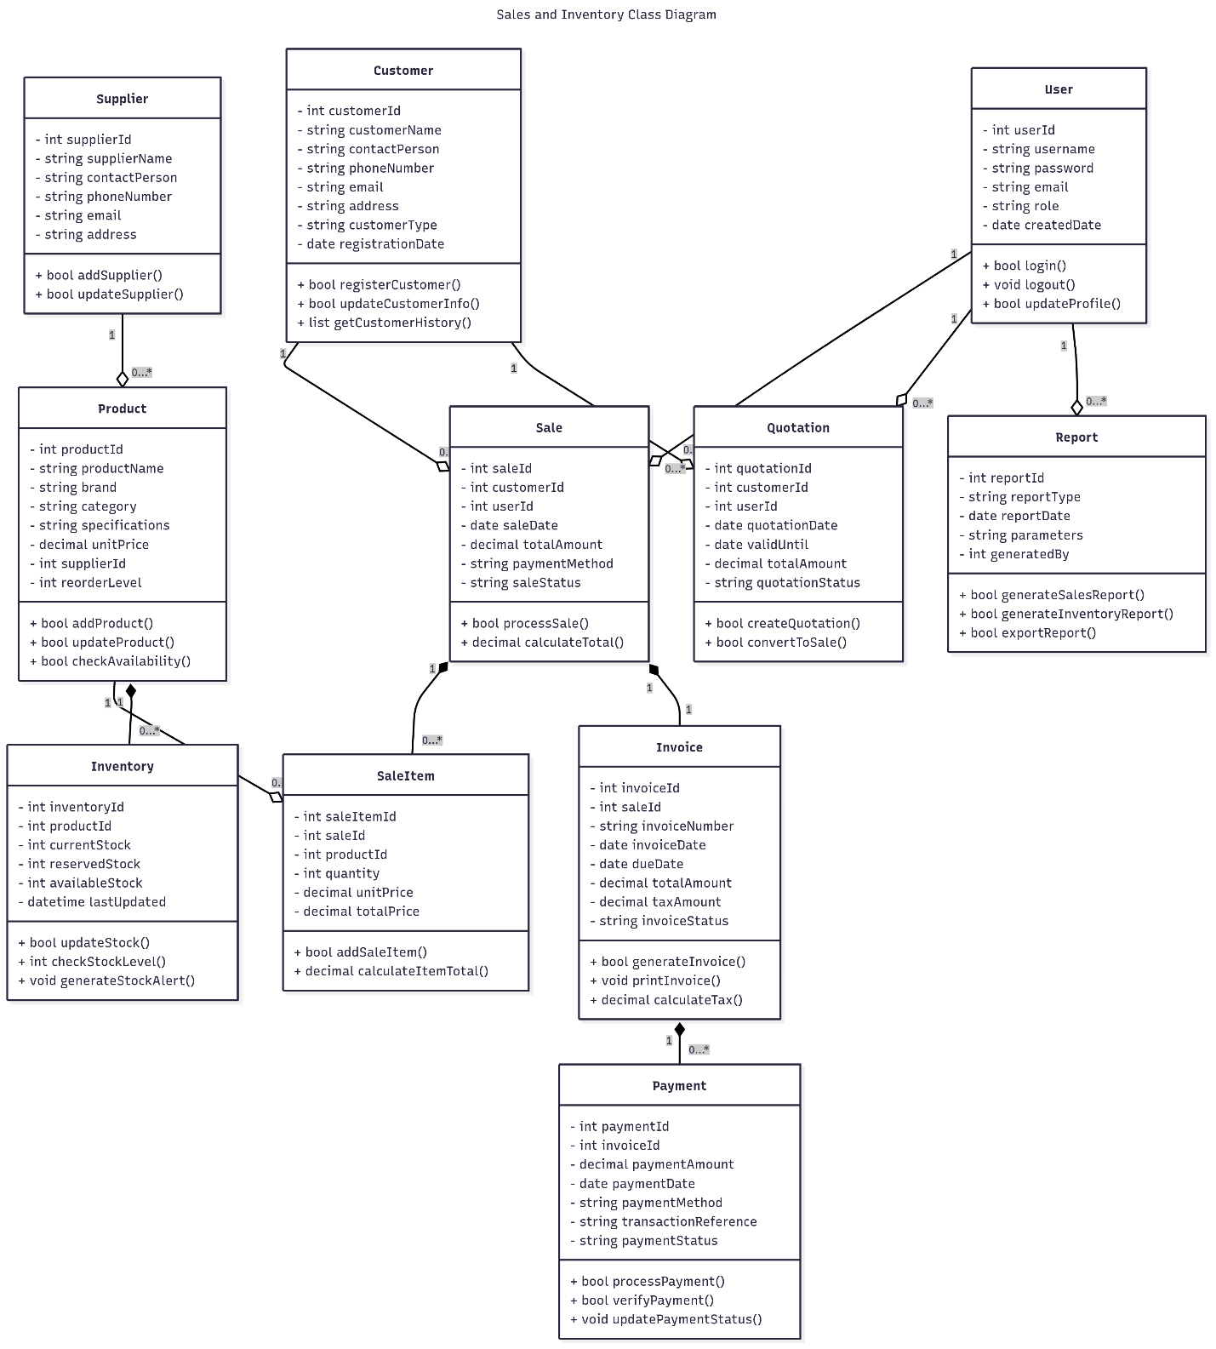
Key entities and their relationships are depicted in the class diagram for the Sales and Inventory Management System. User, Customer, Product, Inventory, Supplier, Sale, SaleItem, Invoice, Payment, Quotation, and Report are among the classes it contains. The User class controls role-based access and authentication, the Customer class keeps track of customer data, and the Product class specifies inventory items along with their costs and specifications. While the Sale and SaleItem classes handle transactions, the Inventory class keeps track of stock levels and availability. Billing and financial transactions are managed by the Invoice and Payment classes, while pre-sales activities are supported by Quotation and business analytics are provided by Report.

CLASS | ATTRIBUTES | METHODS | RELATIONSHIP
USER | - int userId: string  - username: string  - password: string  - Email: string  - date: createdDate | - login()  - logout()  - updateProfile()  - changePassword()  - int getUserId()  - string getRole() | Associates with Sale, Quotation, and Report: a User can be associated with many Sales, Quotations, and Reports.
CUSTOMER | - int customerId: string  - customerName: string  - contactPerson: string/phoneNumber  - email: string  - customerType: string  - registration: Date | - registerCustomer()  - updateCustomerInfo()  - getCustomerHistory() | Associates with Sale and Quotation: a Customer can have many Sales and many Quotations.
SUPPLIER | - supplierId: string  - supplierName: string  - contactPerson: string/ phoneNumber  - Email: string  - Address: string | - addSupplier()  - updateSupplier()  - getSupplierInfo()  - getSupplierId() | Associates with Product: a Product has one Supplier.
PRODUCT | - productId: string  - productName: string  - brand: string  - Category: string  - unitPrice: int  - supplierId: int  - reorderLevel: string | - addProduct()  - updateProduct()  - deleteProduct()  - getProductInfo()  - checkAvailability() | Associates with Inventory and SaleItem: a Product can have one Inventory record and can be part of many SaleItem.
INVENTORY | - inventoryId: int  - productId: int  - currentStock: int  - reservedStock: int | - updateStock()  - checkStockLevel()  - calculateAvailable()  - generateStockAlert()  - getInventoryStatus() | Aggregation with Product: one Inventory record tracks one Product.
SALE | - saleId: int  - customerId: int  - userId: int  - saleDate: date  - totalAmount: string  - paymentMethod: | - processSale()  - calculateTotal()  - updateSaleStatus()  - getSaleDetails()  - generateInvoice() | Associates with Customer and User. Composition with SaleItem: a Sale is composed of many SaleItem.
SALEITEM | - saleItemId: int  - saleId: int  - productId: int  - quantity: decimal  - unitPrice: decimal  - totalPrice: int | - addSaleItem()  - updateQuantity()  - calculateItemTotal()  - getSaleItemDetails() | Associates with Product and Sale: a SaleItem is a part of a Sale and corresponds to a Product.
INVOICE | - InvoiceNumber: int  - date invoiceDate:  - dueDate: decimal  - totalAmount: decimal  - taxAmount: string | - generateInvoice()  - updateStatus()  - calculateTax()  - printInvoice()  - sendInvoice() | Associates with Sale and Payment: an Invoice is generated from a Sale and can have many Payments.
PAYMENT | - paymentId: int  - invoiceId: int  - paymentAmount: decimal  - paymentDate: date  - paymentMethod: string  - transactionReference: string | - processPayment()  - verifyPayment()  - updatePaymentStatus()  - getPaymentDetails() | Associates with Invoice: a Payment is made for an Invoice.
REPORT | - reportId: int  - reportType: string  - reportDate: date  - parameters: string  - generatedBy: string | - generateSalesReport()  - generateInventoryReport()  - generateFinancialReport()  - exportReport() | Associates with User: a Report is generated by a User.

Behavioral
- User Authentication Sequence Diagram
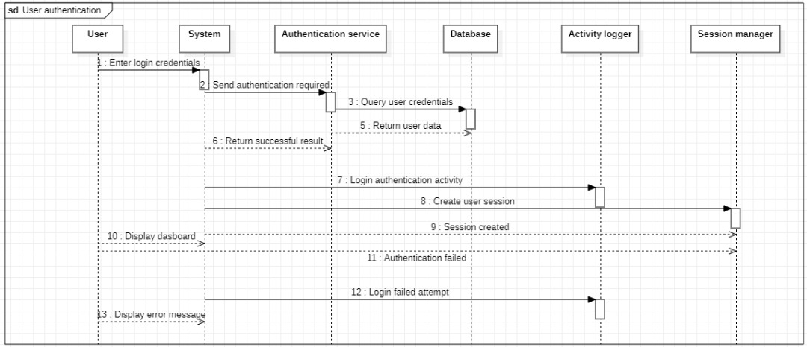Narration
The first thing a user does is input their login information, which the System forwards to the Authentication Service. The credentials are verified by the service using user information that was obtained from the database. The system logs the action, establishes a user session, and shows the user the dashboard if the authentication is successful. If authentication is unsuccessful, though, the system records the unsuccessful attempt and notifies the user of the problem.
- Customer management sequence diagram
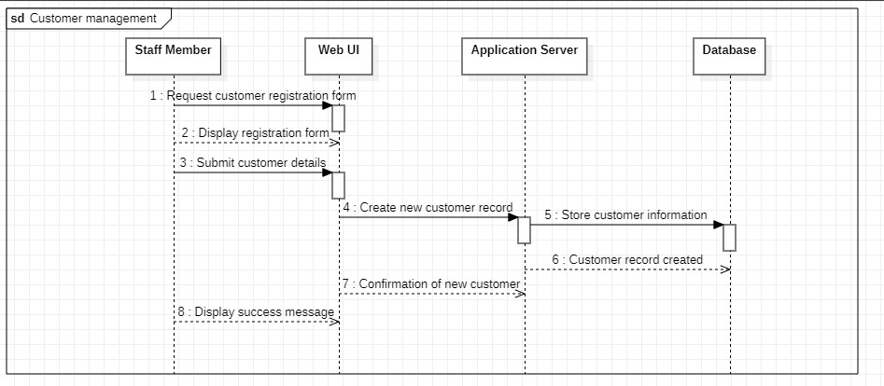Narration
The initial step that a staff member does is ask the online interface for the customer registration form. They receive the form, complete it, and then submit the new customer's information. The application server, which is in charge of generating a new record and keeping the data in the database, receives this information from the system's web user interface. The application server sends a confirmation back to the web user interface (UI) when the database verifies the successful storage. This completes the registration process by displaying a success message to the staff member.
- Product Inventory Management Sequence Diagram

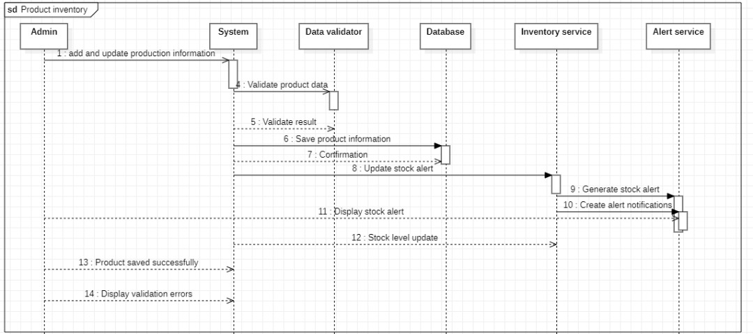Narration
The system first forwards the information to a data validator when an administrator adds or modifies product details. The system notifies the administrator of validation problems if the data is deemed invalid. The system updates the stock levels by triggering the Inventory Service after saving the data to the database if it is legitimate. When the new stock drops below the reorder level, the Inventory Service uses the Alert Service to create and show the admin a stock alert. The administrator is then notified by the system that the product data was successfully saved.

- Sales Transaction Processing Sequence Diagram

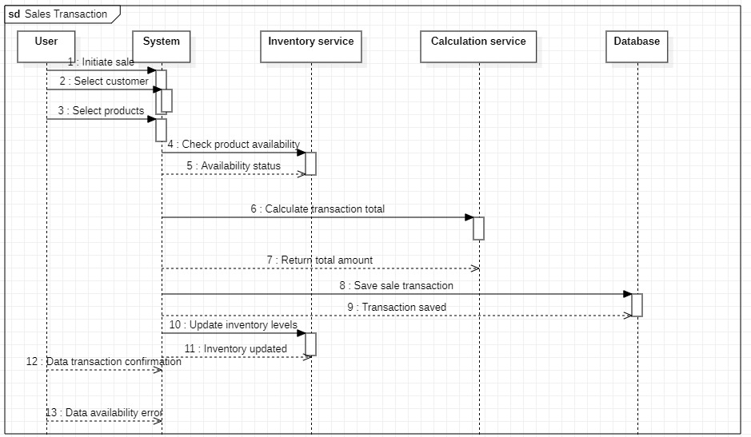Narration
The System checks product availability with the Inventory Service when a user chooses a customer and products to start a transaction. The system then uses the Calculation Service to determine the entire price of the transaction, including taxes and discounts, if the products are available. After that, the user receives a confirmation, the transaction is stored to the database, and the inventory levels are updated. If the products are not accessible, however, the procedure finishes right away and the user is notified of the issue.

- Invoice Generation Sequence Diagram

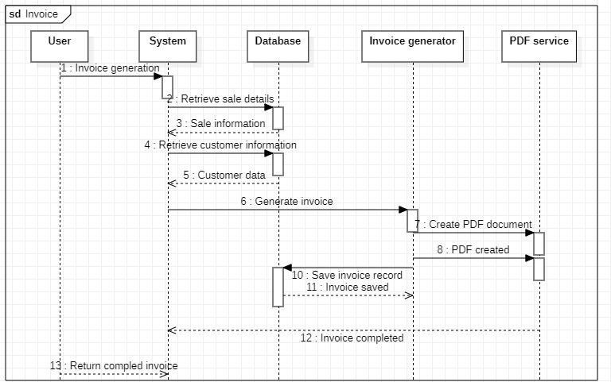Narration
When a user asks the system for an invoice, the procedure starts. Initially, the system pulls the client and sale data from the database. This information is then sent to the Invoice Generator, which computes totals, uses the PDF Service to produce a PDF document, and stores the completed invoice record back to the database. Lastly, the user receives the completed invoice back from the system.

- Payment Processing Sequence Diagram

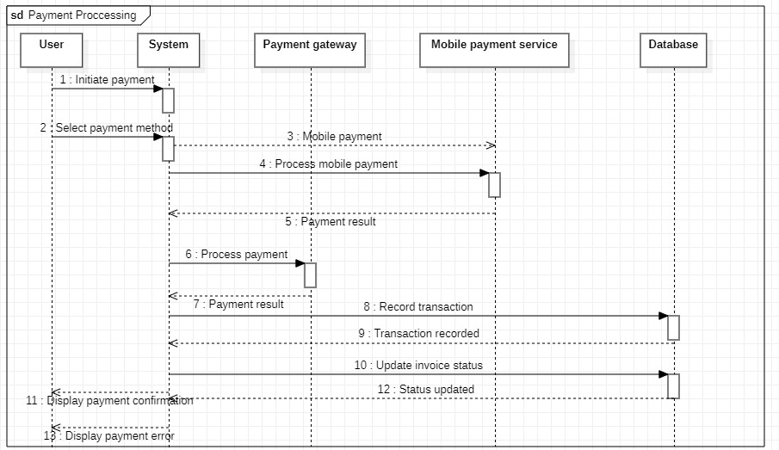Narration

First, a user chooses their preferred payment method and initiates a payment. Depending on the user's preference, the system then directs the payment through either a payment gateway or a mobile payment service. Before showing the user a confirmation, the system logs the transaction and modifies the invoice status in the database if the payment was successful. On the other hand, the system instantly displays an error message to the user in the event that the payment fails.

- Stock Level Monitoring Sequence Diagram

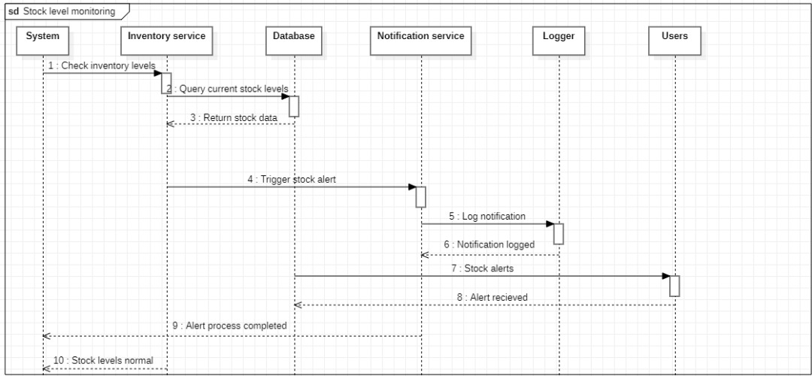Narration
By making a database query, the system's inventory service automatically verifies the current stock levels. One of two things happens once the stock is compared to a minimal threshold: if the stock is low, it triggers and logs an alert that is delivered to users; if the stock is normal, the process ends without taking any further action.

- Financial Reporting Sequence Diagram

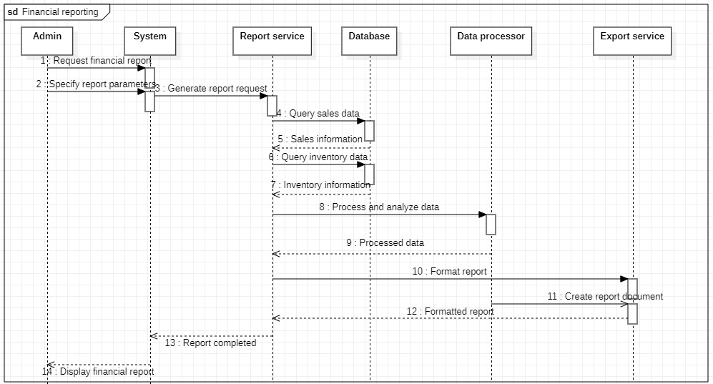

Narration
The sequence diagram illustrates financial reporting functionality. The admin requests a report with specific parameters, the report service queries sales and inventory data from the database, processes and analyzes the information, formats the report through the export service, and displays the completed financial report to the admin.

- Quotation management sequence diagram
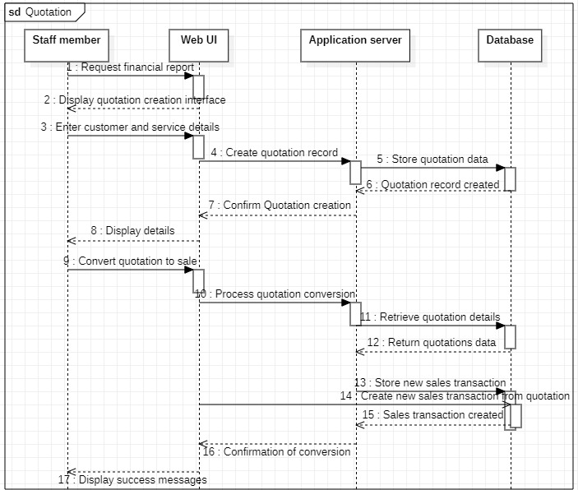
Narration
When a staff member generates a quote, the system confirms it by saving it to the database. The employee turns that quote into a sale later on. In order to conduct the new sales transaction and verify the successful conversion, the system fetches the original information.

References
datacamp, 2024. datacamp. [Online]
Available at: https://www.datacamp.com/tutorial/structural-equation-modeling
[Accessed 21 August 2025].
geeksforgeeks, 2025. geeksforgeeks. [Online]
Available at: https://www.geeksforgeeks.org/system-design/unified-modeling-language-uml-class-diagrams/
[Accessed 21 August 2025].

Appendix
Class diagram appendix
Symbol | name
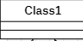 | class | This describes the operations and properties of an object or entity.
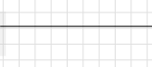 | association | Indicate that objects from a distinct class will interact with objects from another separate class (softwareengineering.stackexchange, 2025).
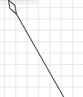 | aggregation | Demonstrates that the items it contains can exist independently (javapapers, 2025).
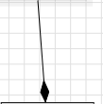 | composition | On this relationship, objects in one class are destroyed, which destroys other objects in the other class (medium, 2025).
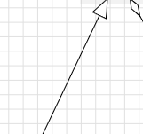 | Generalization | This demonstrates that there is inheritance between classes (softwareengineering.stackexchange, 2025).

Sequence diagram appendix
Symbol | name
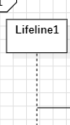 | Life line or object
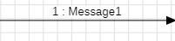 | message
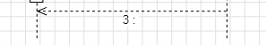 | Reply message
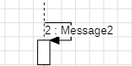 | Self reply

